DRDP (2015)--Infant/Toddler© Documentation Samples
Anecdotal Notes, Photos, and Work Samples

Noel 13 months 8-10
Noel and two friends played peek-a-boo in the playhouse. They opened and closed the windows. While standing, N stuck his head out of the window and said, “Boo!” then laughed.
Measures – SED 4 & 9, LLD 3, COG 2 & 3, PD-HLTH 1

Abba - 14 months. 8-23
I asked “Who’s that?” (I pointed to the photo of Abba with mom.) He said, “Mama.” He continued to look carefully and then pointed to himself.
Measures- SED 1, 2 & 9, LLD 1, 2 & 3

Mac 11 months 9-17
Mac and Sophia sang a song along with Joan. He clapped his hands, smiled at the others. He vocalized sounds, following the beat of the song as he sang along.
Measures- SED 3, LLD 5, COG 2, PD-HLTH LLD4

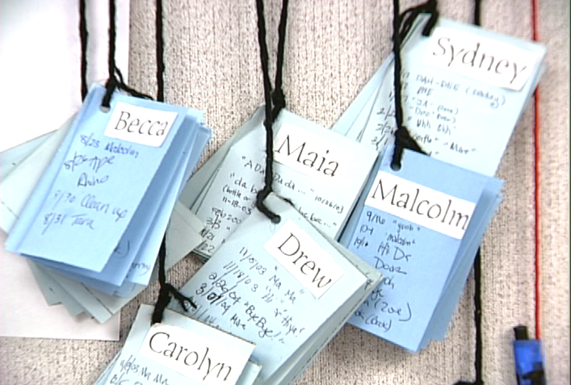

First Words

We document each infant’s way of expression so we can witness the wonderful way that language develops in each individual. We record the date and the sounds/words the children express. Parents can also add to the First Word lists. This information helps staff and parents scaffold infants’ language and connect his/her home and school life.

Note: Evidence to document for Measure LLD 3 – Communication and Use of Language (Expressive)

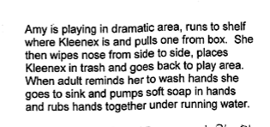
10/12
Amy typically uses a tissue when her nose is runny. She blows and wipes and usually remembers to wash hands.

NOTE: Understanding of Language (Receptive) LLD 1, Cause & Effect COG 8, Personal Care Routines PD-HLTH 4 & 6

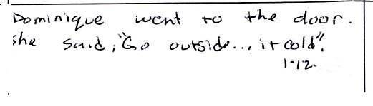
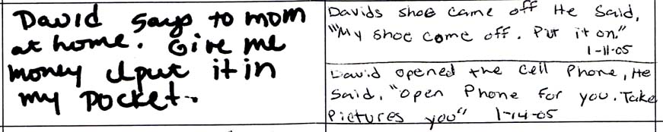
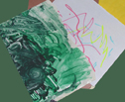

3/15 - Finger painting and marker drawing samples by Cia at 20 months.

Excerpt from M. J.’s Daily Journal
Age: 15 months

Monday – 10/3
8:40 – Arrives at center. Smiles and says “hi.” Puts bag and jacket in his cubby.

9: 10 - M holds a cup with one hand, and with the other pushes the button of the water fountain to fill his cup.

9:45 – Outdoor playground - M. picks up a basketball and throws it up in the air using both hands.

10:00 – Playground - M goes up the climber and walks across the bridge, back and forth. He yells to others playing in the sand below the climber. Smiles and waves when they look up at him.

10:10 - Bike path - M uses the play tool to pretend to fix the bike wheels.

11:20 – Book corner - M sat in the book area looking at books for about 10 minutes. She named many things she saw and pointed to in the book, e.g., “dog…baby… toy.”

11:40 – Nap time – M goes to his cubby to get his “blankie.” He rubs his eyes, and comes to sit on my lap. He watches others, lays his head against my shoulder. I asked, “Are you ready to nap?” He holds his blankie tighter, says nothing. He walks to nap area and snuggles with blankie. Falls asleep quickly and sleep until 1:15.

