Getting Started: DRDP Online for Administrators

Administrator Role

Agency Administrator

An agency administrator may access information pertaining to the teachers. An account that is assigned the role of agency administrator has access to DRDP records for the children under the care of all the teachers at every site. An agency administrator has the following permissions:

- Create and edit sites
- Set rating periods used by sites
- Create, edit, view, and/or search child
- Re-enroll and/or reassign children
- Enroll or withdraw child from classes
- Create, edit and/or view classes
- Assign all personnel and children to classes
- View, lock and/or unlock child’s DRDP record
- View and run reports

Site Administrator

Like an agency administrator, a site administrator also has information pertaining to the teachers. An account that is assigned the role of site administrator has access to DRDP records for the children under the care of all teachers at one site, therefore site administrator can be assigned to multiple classes. A site administrator has the following permissions:

- Create, edit, view, and/or search child
- Re-enroll and/or reassign children
- Enroll or withdraw child from classes
- Create, edit and/or view classes
- Assign teachers, coaches, data analyst to classes
- Add teachers
- View and lock ratings
- View and run reports

Getting Started

Log In:
Go to the DRDP Online website: www.drdponline.org

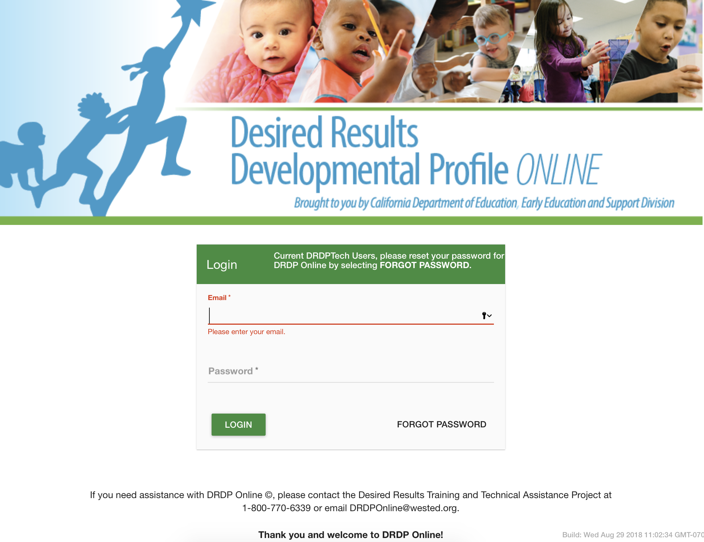Figure 1. Login Page

Enter User Name/Email:
For previous DRDPtech users, login with your DRDPtech username. This is your complete email address (e.g., jsmith@school.net).

Password:
For previous DRDPtech users, the first time you log into DRDP Online select Forgot Password on the bottom right-hand corner (see Figure 1). After verifying your email address, the system will send you an email with a prompt to reset your password.

For first time DRDP Online users, when your account is created, you will receive an email from the DRDP Online system with a prompt to set your password (see Figure 1).

Adding Users/Sites
Additional users may be added by choosing Create User Account at the middle left section of the navigation menu.

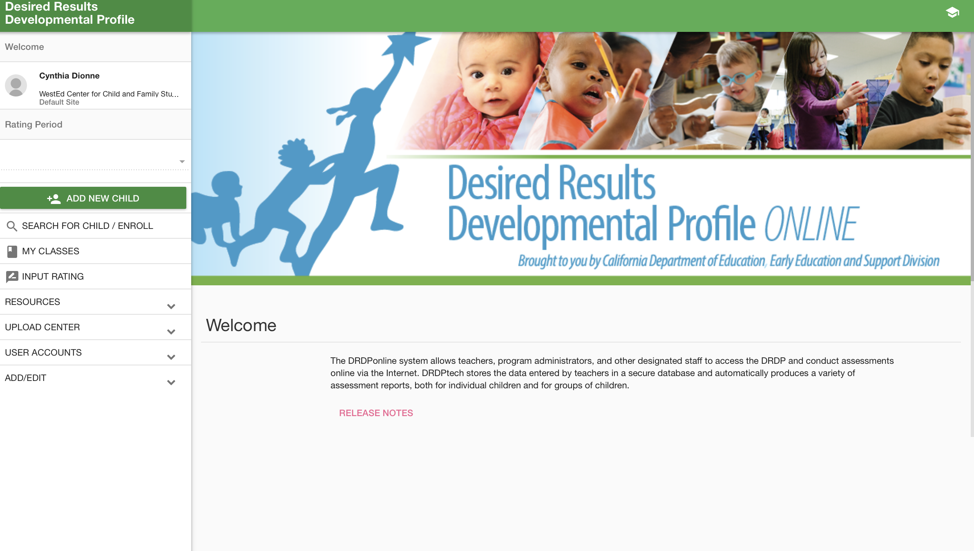
Figure 2. User Accounts

Once a user is created, choose the pencil icon to determine the role for that account. In the pop-up box, choose the second tab, Role.

For entering additional sites into the system, go to the Navigation Menu (left side of the screen) and choose Add/Edit and Sites. Input the site information and choose the green button with the + sign on the top right.

Classes and Children

In the Navigation Menu, under Add/Edit are the basic functions for adding classes. Choose Classes and choose the green button with the + sign on the top right.

To add children, in the Navigation Menu, choose the green Add New Child.

Add New Child:
Important: When adding a child, enter the Statewide Student Identifier (SSID). If you do not have an SSID, you may leave that field blank. However, you must provide the Agency/District Identifier. Each child in an agency has a unique ID. The agency/district ID is important because DRDP Online uses it to monitor children’s developmental progress from one rating period to another.

Move Child Record:
Administrators can only re-enroll or reassign children. Site administrators can reassign or re-enroll all children within a site.

Reassign Child/Children: To move child/children from one class to another within the same rating period, search for the child or children that need to be moved. Once a list generates, select the red plus sign next to the child/children (see Figure 3). Those children will be put into the “cart” (the white graduation cap at the top right corner). When there are children in the “cart” a red circle with the number of children will display (See Figure 3). Select the white graduation cap. On the next page, choose the green Manage Enrollment button. A box will display in which the site and classroom can be chosen. The child’s information and ratings are then moved to that class. Children (and their ratings) are reassigned from Class A to Class B for that rating period.

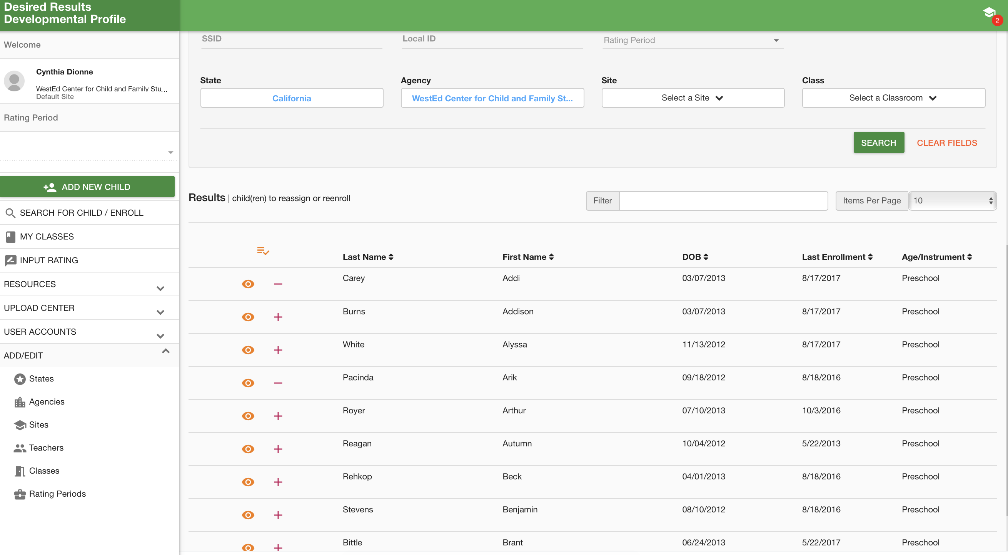
Figure 3. Moving Children

Re-enrolled Child: Children can be re-enrolled from one assessment period to another. To re-enroll children, select Search for Child/Enroll. Like the steps for re-assigning children, once a list generates, you will select the red plus sign next to the child/children (see Figure 3). Those children will be put into the “cart.” Select the white graduation cap. On the next page, choose the green Manage Enrollment button. When the box displays, choose the rating period in which you wish to re-enroll the child/children. This will copy the child/children along with their information from a past rating period to the current rating period. DRDP measure ratings are not copied. Re-enrolling a child from Rating Period A to B does not delete the child information from Rating Period A; it is copied into Rating Period B.

Helpful Resources for DRDP Online

To access complete information on DRDP Online and instructions for all users, visit the DRDP Online section on the Desired Results website http://www.desiredresults.us. Register for DRDP Online webinars on the Training section of the Desired Results website.

