Getting Started: DRDP Online for Teachers

Teachers

A teacher may access information pertaining to the group of children under their care and is responsible for completing the DRDP for each child during a rating period. DRDP Online has two roles for teachers: Teacher and Teacher of Record. These roles have the following permissions:
- Search for and view child/children
- View classes
- Enter, view, edit, and/or lock child ratings
- Run and view reports
- View teachers assigned to your class

Accounts assigned either the Teacher or Teacher of Record role can be assigned to multiple classes. In addition, classes can have multiple Teachers and/or Teachers of Record assigned.

Getting Started

Log In:
Go to the DRDP Online website: www.DRDPonline.org

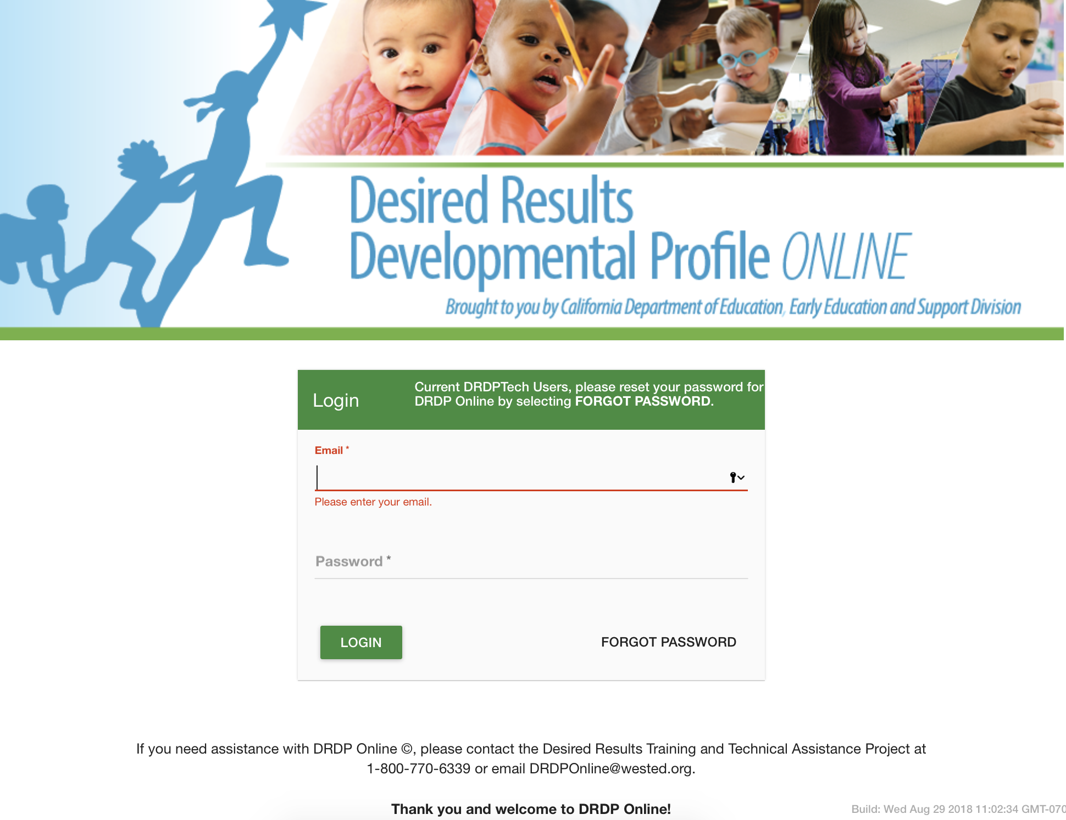
Figure 1. Login Page

Enter User Name/Email:
For previous DRDPtech users, enter your DRDPtech username. This is your complete email address (e.g., jsmith@school.net).

Password:
For previous DRDPtech users, the first time you log into DRDP Online select Forgot Password at the bottom right-hand corner (see Figure 1). After verifying your email address, the system will send you an email with a prompt to reset your password.

For first time DRDP Online users, when your account is created, you will receive an email from the DRDP Online system with a prompt to set your password.

Classes and Children

In DRDP Online, teachers do not have the capability of adding a class or child record. This is a permission assigned to an administrator or data entry role.

Rating
To enter ratings into DRDP Online, select Input Ratings at the middle left section of the navigation menu (see Figure 2).

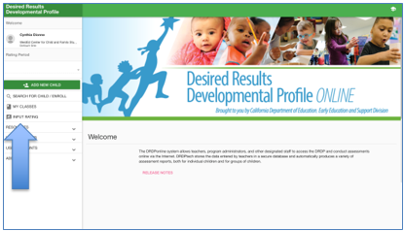
Figure 2. Input Ratings

A list of children in the class will be displayed. To the right of each child’s name the domains will be listed with the number of measures assessed within each domain (see Figure 3). Select the domain listed for a child to begin inputting ratings.

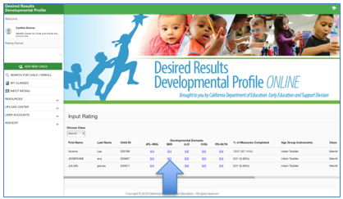
Figure 3. Input Ratings

Ratings can then be entered on the next page for the domain selected. You may move between domains by clicking on the drop-down menu of domains below the teacher’s name (see Figure 4). This drop-down menu provides the option of rating/viewing one domain at a time or viewing all domains at once. For each measure, select the developmental level by selecting the circle for that level. Once a level is chosen, if the child is emerging to the next level, emerging (EM) can also be marked by clicking on the box to the right (see Figure 4). If a child has had excessive absences, unable to rate (UR) can be marked by selecting the box to the right (see Figure 4).

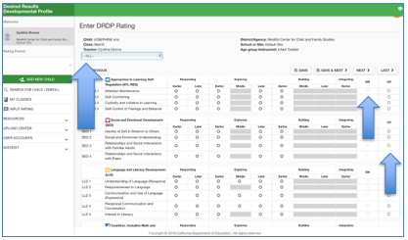
Figure 4. Enter DRDP Ratings

Helpful Resources for DRDPtech

To access complete information on DRDP Online and instructions for all users, visit the DRDP Online section on the Desired Results website http://www.desiredresults.us. Register for DRDP Online webinars on the Training section of the Desired Results website.

