Entering Ratings
To enter ratings into DRDP Online, select Input Ratings at the middle left section of the navigation menu (see Figure 1).

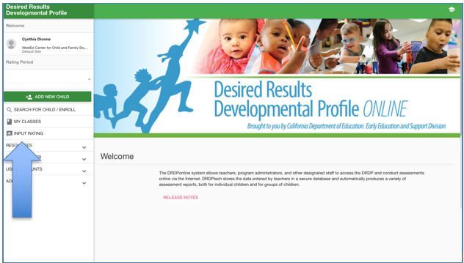Figure 1. Input Ratings

A list of children in the class will be displayed. To the right of each child’s name, the domains will be listed with the number of measures assessed within each domain (see Figure 2). Select the domain listed for a child to begin inputting ratings.
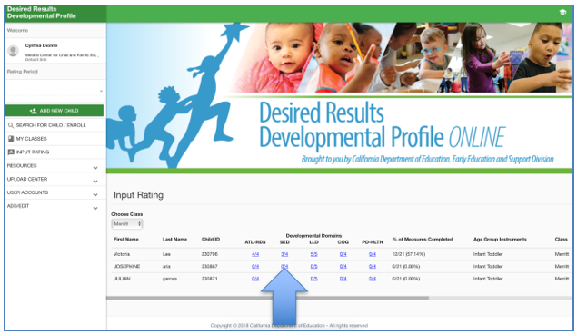
Figure 2. Input Ratings

Ratings can then be entered on the next page for the domain selected. You may move between domains by selecting the drop-down menu of domains below the teacher’s name (see Figure 3). This drop-down menu provides the option of rating/viewing one domain at a time or viewing all domains at once. For each measure, select the developmental level by selecting the circle for that level. Once a level is chosen, if the child is emerging to the next level, emerging (EM) can also be marked by selecting the box to the right (see Figure 3). If a child has had excessive absences, unable to rate (UR) can be marked by selecting the box to the right (see Figure 3).
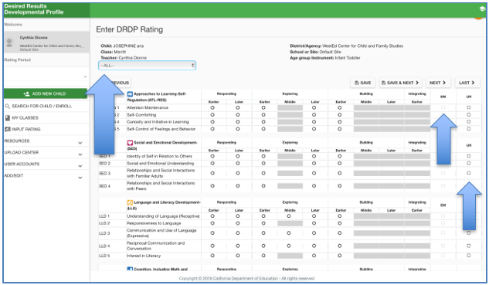
Figure 3. Enter DRDP Rating

Helpful Resources for DRDPtech

To access complete information on DRDP Online and instructions for all users, visit the DRDP Online section on the Desired Results website http://www.desiredresults.us. Register for DRDP Online webinars on the Training section of the Desired Results website.

