Move Child Records

Only administrators can re-enroll or reassign children. Site administrators can reassign or re-enroll all children within a site.

Reassign Child/Children: To move a child or children from one class to another within the same rating period, first search for the child or children that need to be moved. Once a list generates, select the red plus sign to the left of the child/children (see Figure 3). Those children selected will be added to a cart. (The white graduation cap at the top right corner indicates your cart.) When there are children in the cart, a red circle with the number of children will be displayed (See Figure 3.) Select the white graduation cap to view the children in the cart, then select the green Manage Enrollment button. A box will appear in which the site and classroom can be chosen. The child’s information and ratings will be moved to the selected site and class for that rating period.

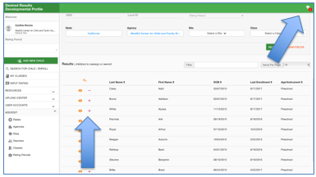

Figure 3. Moving Children

Re-enroll Child/Children: Children can be re-enrolled from one assessment period to another. To re-enroll children, select Search for Child/Enroll. Like the steps for re-assigning children, once a list generates, select the red plus sign to the left of the child/children (see Figure 3) to move those children into the cart. Select the white graduation cap to view the children in the cart, then select the green Manage Enrollment button. When the box appears, select the rating period in which you wish to re-enroll the child/children. This will copy the child/children along with their information from a past rating period to the chosen rating period. DRDP measure ratings are not copied. Re-enrolling a child from Rating Period A to B does not delete the child information from Rating Period A; it is copied into Rating Period B.

Helpful Resources for DRDP Online

To access complete information on DRDP Online and instructions for all users, visit the DRDP Online section on the Desired Results website http://www.desiredresults.us. Register for DRDP Online webinars on the Training section of the Desired Results website.

