Report | Description
Group Progress Report  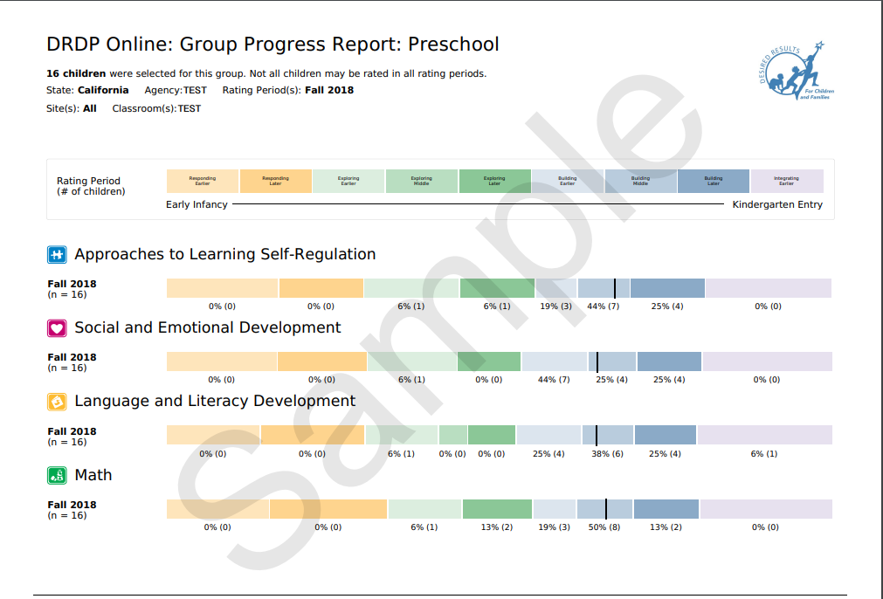 | This report provides scale scores by domain for a group of children and has the number of children at each level in the domain. This report can be pulled for a class, for an agency, or for a specific group of children, such as four-year olds who had ELD measures completed.
Cohort Progress Report  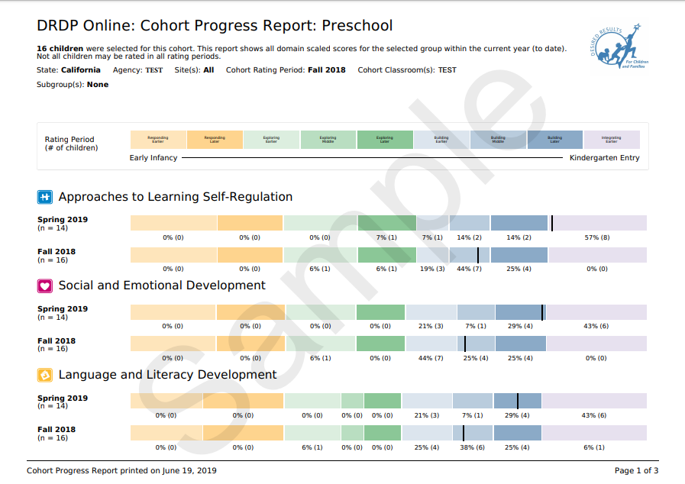 | The Cohort Progress Report provides domain scale scores for a selected group of children. It also provides the ability to select a filter such as program type. The report will show all domain scaled scores for the selected group within the current year (to date).
Child Progress Report  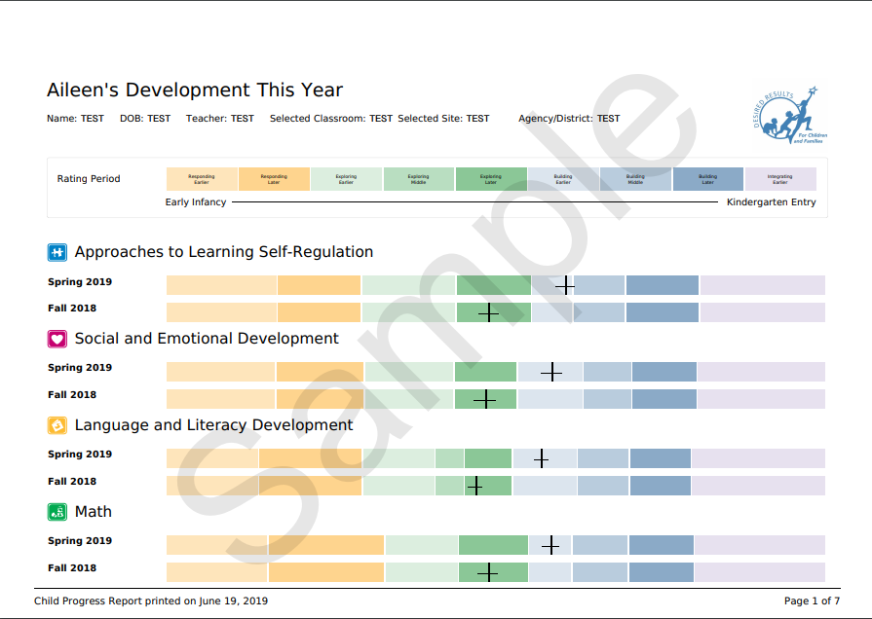 | This report provides scale scores by domain for individual children. It provides a child’s progress using scale scores by domain over two rating periods in the same year within a single age-group instrument. Ratings are grouped by domain.
Parent Progress Report  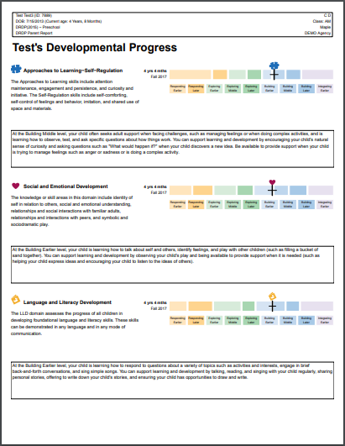 | The Parent Report is a summary report for parent conferences that includes Child Progress over time. It includes graphics and descriptors to show the child’s rating and additional descriptive information about the child’s progress.  DRDP Online Parent Report Feedback Survey
Class Planning Report (Beta)  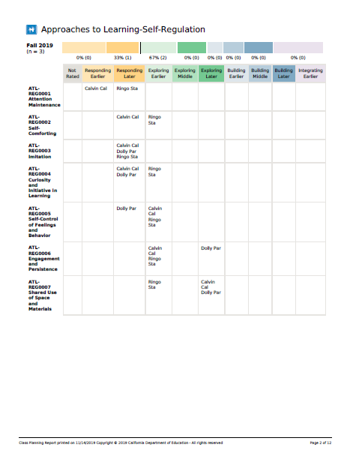 | This report allows users to select a rating period and classroom to generate a report for all the children in the classroom. The report will include scaled scores for these children in all rating periods in the current year.

