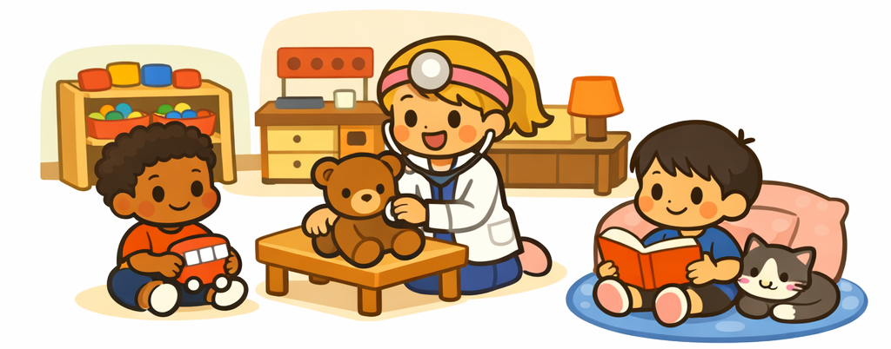
Room Arrangement for Play and Learning

Item 3. A “play area” is a space where play materials are provided for children to use. An “interest center” is a clearly defined area for a particular kind of play.* Materials are organized by type and stored so that they are accessible to the children.

5.2. At least 5 interest centers are used, including a cozy area protected from active play. A “cozy area” is a clearly defined space with substantial softness where children may lounge, daydream, read, or play quietly. The cozy area must provide enough soft furnishings to allow children to fully escape the typical hardness of the early childhood classroom. The term used has the same meaning as 'accessible' for this indicator.

*Explanation of Terms Used Throughout the Scale, pp. 11-12, #6

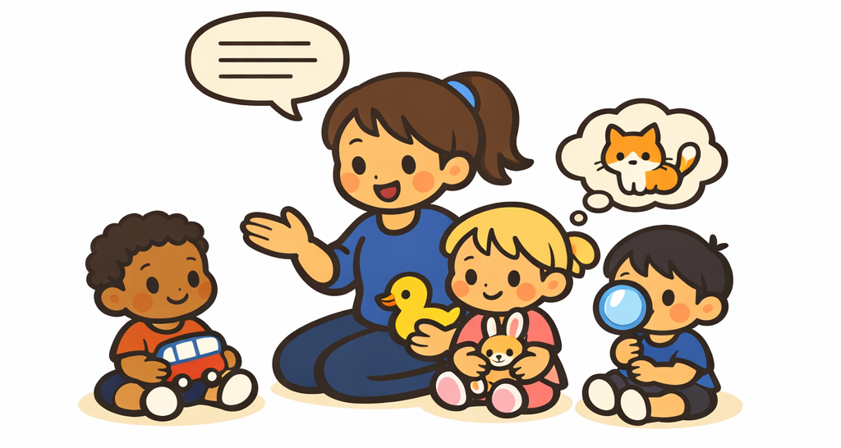
Helping Children Expand Vocabulary

Item 12. All children should generally be well exposed to what is required. If there are long periods of little or no exposure to language from staff, such as a lack of staff circulation during free play, no credit will be given. There should be some language experiences for children during gross-motor time.

5.3 To score a yes, we would need to observe many words being used very often while children play with toys during free play, and also as children participate in routines and group times. This indicator requires ample materials to discuss and increased opportunities for staff to use a wider variety of words with children in meaningful ways.

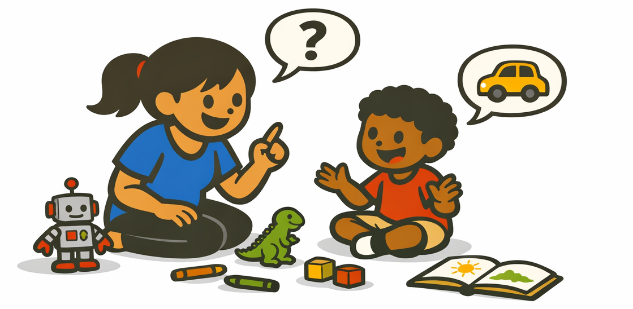
Encouraging Children to Use Language

Item 13. Staff should respond when children address or approach them, such as when children are trying to show or tell a staff member something. Staff must be close enough and show interest and positive responsiveness to encourage a child to initiate communication.

5.4 Staff help children communicate verbally with one another. Staff should be observed asking children to talk to one another or initiating a conversation in which more than 1 child is engaged, all contributing in some way that goes beyond simply listening to another child talking to an adult.



Staff Use of Books with Children

Item 14. The books do not have to be read from beginning to end, but the time should allow for a meaningful experience. Electronic books are considered in this item as long as they are not animated (no moving pictures or print).

5.3 All children participating in the activity are actively engaged during each book time. Book time is any time a book is read to or used with a child or a group of children. It can be formal or informal.

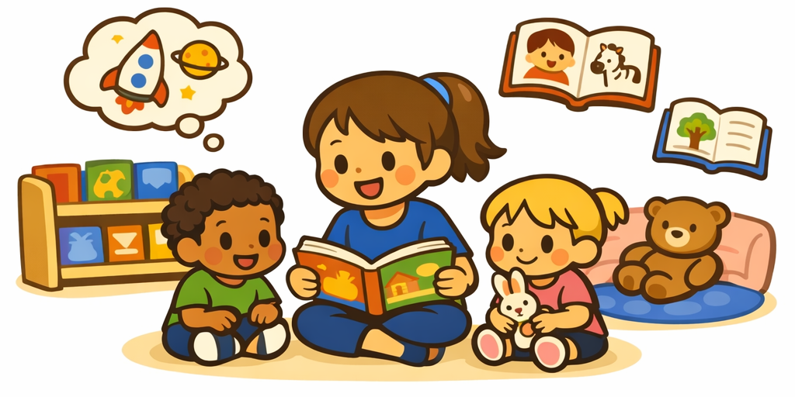
Encouraging Children’s Use of Books

Item 15. A “wide selection of books” includes a variety of topics: people, feelings, nature/science, math, cultures, varying races, males and females, jobs/work, health or self-help skills, sports/hobbies, and abilities. To be given credit for a wide selection, there must be at least 30 books for a group of up to 15 children, and at least one extra book for each additional child over that number permitted to attend. At least five books related to the activity or theme are accessible and observed. However, each topic does not need to be represented.

5.3 The reading interest area must meet the requirements of “interest center.” If unrelated materials are observed in this area and disrupt the use of books, and staff don’t redirect, then the area is not considered a “reading interest center.”

**Explanation of Terms Used Throughout the Scale, pgs. 11-12, #6

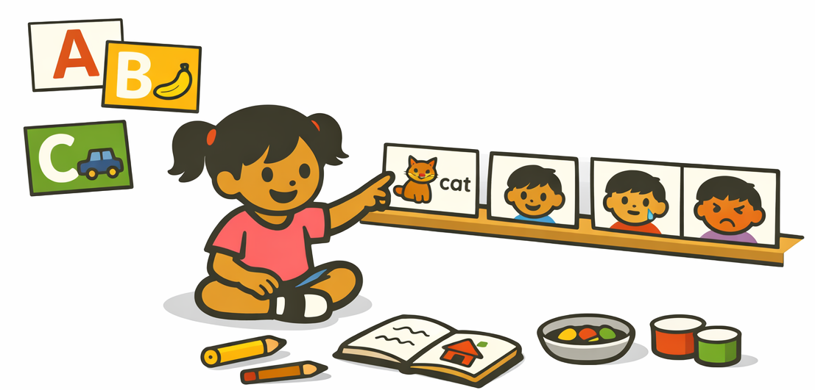

Becoming Familiar with Print

Item 16. All print must be easy for children to see clearly. The print must be obviously connected to what is pictured. At least one-third of the visible print on the display materials must meet this requirement, such as picture/word labels on shelves; pictures of children showing varied emotions, with the words next to each; and letters of the alphabet with pictures of words that begin with that letter.

5.3 Evidence might be found in display materials, such as charts or children’s artwork with their comments written on it, or staff are observed writing for the children. Consider work in the display materials only if it is obvious that it was posted recently. Staff must encourage or guide children as they write down what they have said (for example, about their artwork or a note to someone).

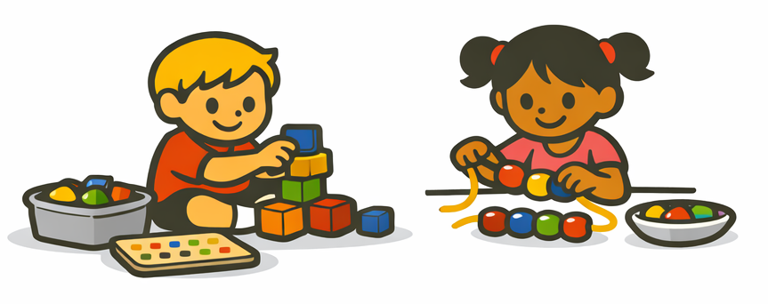

Fine Motor

Item 17. There are several different types of fine motor materials, including interlocking building materials such as interlocking blocks of various sizes; art materials such as crayons and scissors; manipulatives such as beads of different sizes for stringing, pegs, and pegboards, sewing cards; and table blocks; puzzles such as floor and framed puzzles. Materials are accessible to children, and containers are labeled. Staff have conversations with children to expand their language.

5.1 Four kinds of fine motor materials are required, and at least 1 of each type must be accessible. Count only materials that are appropriate for the children’s age and ability.

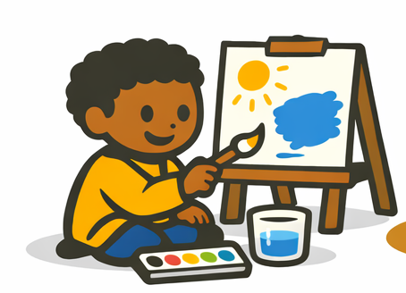
Art

Item 18. Categories of art materials: drawing materials such as crayons, nontoxic watercolor markers, pencils, chalk; paints such as tempera, watercolor sets, finger paints; three-dimensional objects such as play dough, wood scraps, clay, boxes; collage materials such as cloth scraps, yarn, colorful or textured paper scraps; tools such as scissors, tape, hole punches, rulers, stencils, stamps with pads. All materials must be accompanied by paper, as needed, or other surfaces to carry out artwork.

5.2 Most art activities allow children to use materials in their own way. Consider how children use art materials, and how children’s art is displayed in the room. There should be evidence of no more than two examples of teacher-directed projects where children follow an example.

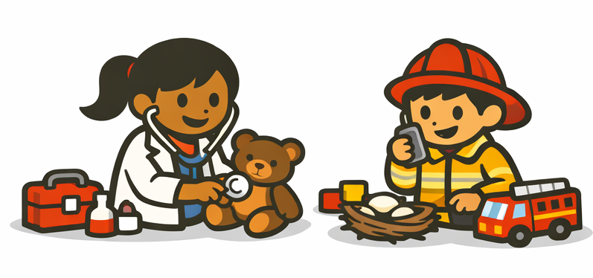

Dramatic Play

Item 21. In the dramatic play area, children must be free to use the materials in their own ways, their own make-believe play. Additional props to use should be accessible, such as additional housekeeping toys and materials from other themes, such as different kinds of work (recognizable equipment and clothing: office staff, doctors, shopkeepers, restaurant staff, firefighters, police); fantasy (a variety of non-frightening costumes and props); and leisure (camping, sports). There should be a wealth of materials for children to use in their pretend play.

5.3 Staff is circulating the dramatic play area and having conversations with the children as they play, joining but not taking over (relating play to home experiences, roles children are playing).

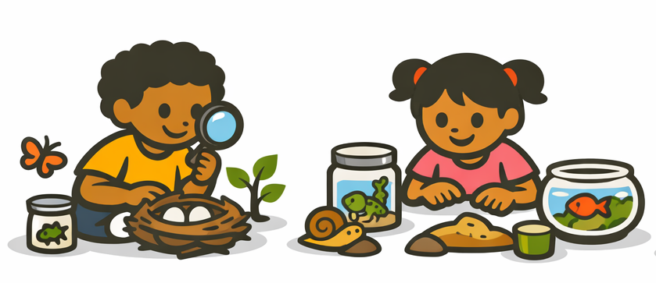

Nature/Science

Item 22. Nature science materials include the following categories: living things to observe closely or care for (e.g., house plants, pets, an outside garden); nature objects (e.g., bird’s nest; leaves; insects in transparent plastic; rocks; seashells; collection of seeds); factual books/nature-science picture games; tools (e.g., magnifying glasses; magnets); sand or water with toys (e.g., measuring cups, digging tools and containers). When scoring sand/water experiences, there should be enough sand or water so children can dig, scoop, pour, fill, and empty containers.

5.1 At least 15 nature/science materials, some from each of the five categories, are accessible in a defined nature/science interest center. A garden cannot be counted to meet this requirement.

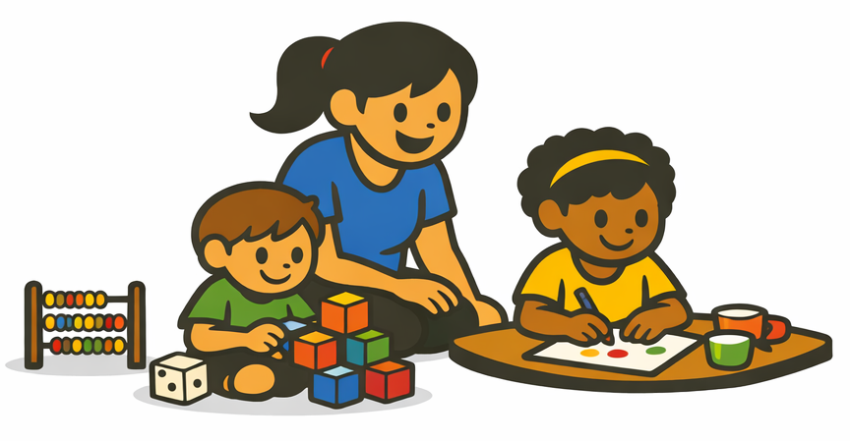

Math Materials and Activities

Item 23. Math materials are those that children can play with to learn and practice math concepts. Materials must be appropriate, safe, and free of negative social messages; they should challenge and interest children without leading to constant wrong answers or frustration. Math materials include the following: counting/comparing quantities such as unifix cubes with number trays, small objects to count into numbered containers, dominos, playing cards, games with dice, abacus; measuring/ comparing sizes and parts of wholes (fractions) such as measuring cups and spoons, balance scale, rulers, yardsticks, tape measures, thermometers, puzzles with geometric shapes; familiarity with shapes such as shape sorters, geoboards, attribute blocks of different sizes, shapes, colors. Math activities are teacher-initiated and -directed and go beyond the children’s use of materials in free play with teacher input.

5.1 At least 10 different appropriate math materials, with at least 3 from each of the 3 categories, are accessible.

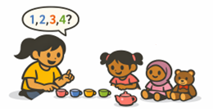

Math in Daily Events

Item 24. “Daily events” include parts of the daily schedule, such as playtimes, non-math large- and small-group times, transitions, and routines. “Math in daily events” refers to the use of math vocabulary and concepts in non-math activities.

5.2 Staff engage children in conversation about math as they play in non-math areas, for example: discuss using measuring cups to water plants, count how many teacups are needed for dolls, and talk about how to measure feet in a play shoe store. Both staff and child are required to contribute to the conversation with interest.

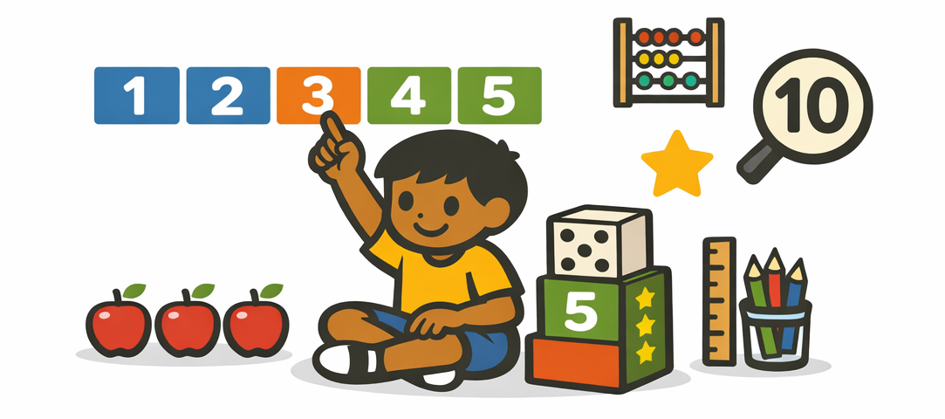

Understanding Written Numbers

Item 25. Examples must be easily visible to the children, and the children must be able to clearly see the relationship between the printed number and the quantity it represents. At least five different appropriate materials that help children attach meaning to print numbers are accessible.

5.3 Staff show children how to use materials and talk about the meaning of printed numbers, for example: count objects with the child and read the number; use “first, second, third” as the child uses the printed number sequence; point out numbers on rulers or thermometers, showing how they indicate differences in size or amount. If children obviously know how to use the materials, staff do not need to teach them; instead, they must be observed discussing the meaning of the number symbols.

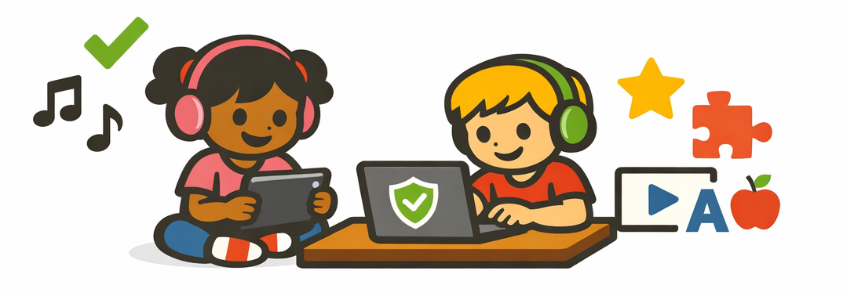

Appropriate Use of Technology

Item 27. If no use of electronic media is observed, score N/A. E-books and music players are not considered electronic media unless they include moving pictures or print. Cameras used by children are not considered here.

5.2 The intent of the indicator is to ensure that children participate in play in which they can actively be creative, imaginative, and have hands-on experiences with real materials, rather than spending inordinate amounts of time watching TV or other passive electronic devices. Time limits do not apply to children with disabilities who use assistive devices for electronic media.

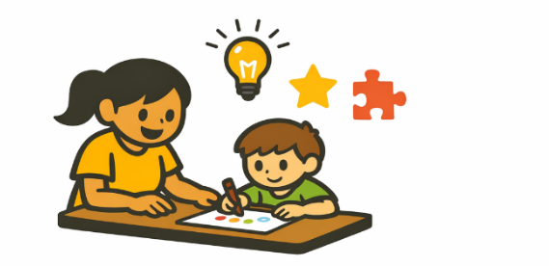
Individualized Teaching and Learning

Item 29. Individualized learning involves responding to variation in the abilities, needs, and interests of children in the group; working with individual children in a systematic way that involves determining the child’s ability to do a task or learn a concept; providing support and encouragement; using appropriate strategies that respond to the child’s needs and interests; and assessing the success of the child in completing the learning task.*

5.2 Staff sometimes circulate through the classroom, adding individualized learning to children’s activities. “Staff sometimes circulate” means that staff do not remain in one or two places throughout free play. Instead, they move about occasionally to interact and teach children playing in different areas.

*Explanation of Terms Used Throughout the Scale, p. 11, #5

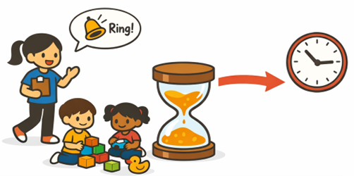

Transitions and Waiting Times

Item 33. Staff prepare and plan for transitions. Staff provide adequate supervision to keep children productively engaged on task during transitions. Children are not required to wait for 10 minutes or more during any transition.

5.2 Staff are almost always prepared for the next activity. To score a “Yes,” there can be no long delays observed, due to staff not being prepared, that cause children to wait for long periods of time.



Whole-Group Activities for Play and Learning

Item 35. “Whole-group activities” are play and other learning activities in which all children do the same thing at the same time. Activities can be done with all children together in one big group. Group activities do not include routines or transitions.

5.2 Staff provide support for children who have trouble participating, for example: allow the child to hold a toy to keep their hands busy while participating; the child can sit on an adult’s lap or a chair. All children participate, and no problems are observed. Needs of all children are being met, and all are engaged with no extra support needed.

