Preschool Documentation
Anecdotal Notes, Photos, and Work Samples

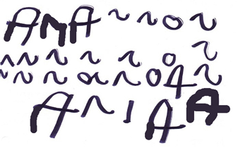
11/18
Ana made the first letter in her name. As she drew the A’s, she said, “a-a-a.” She smiled as she moved the marker to make the letters. She tapped me on the arm and said, “That means ME – Ana!” She spent several minutes on this activity while other children worked around her. She held paper still with left hand and wrote letters holding marker in right hand.
Measure #’s – SED 1, SED 3, LLD 3, LLD 7, LLD 8, LLD 9, LLD 10, and PD-HLTH 4

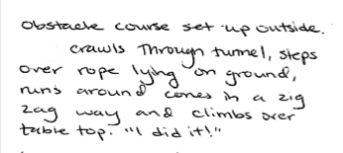
01/16
Evidence of Pablo’s complex movement skills during play – LLD 3, PD-HLTH 1, PD-HLTH 2

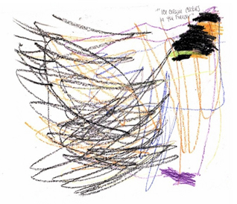

9/20
Amy made circular scribbles with the crayons. As she added different colored swirls, she said, “This is ice cream…” She made other circles and said, “And these are cookies… ice cream and cookies. I like them!”
SED 2, LLD 3, LLD 10, VPA 1

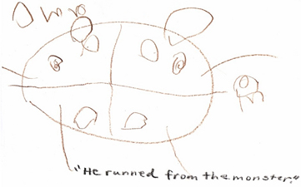

11/12 Amy
Drawing and retelling a monster story LLD 3, LLD 5, LLD 6, LLD 10, VPA 1

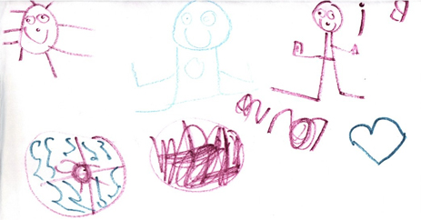
6/16 Amy
Drawings of her friends in the pool VPA 1, LLD 10
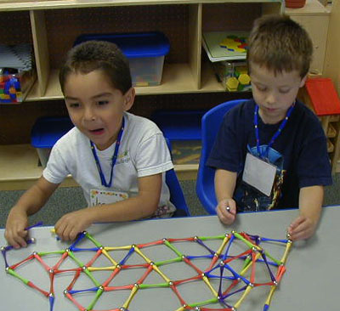
10/24

Jorge and Derek played at the manipulatives table with the straw builders. They took straws from the bin, sharing the stack. They worked side-by-side connecting the straws into one large structure. They did not talk about what they were building. They worked for 20 minutes on structure.

ATL-REG 7, SED 4, PD-HLTH 4

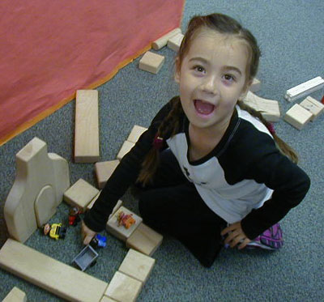
12/17

B. said, “I built a castle with the blocks.” She pointed to a room, “This is where the princess sleeps and plays with her friends.”
She moved the character around and hummed a tune. “She likes to dance.”
LLD 3, VPA 2, SED 5

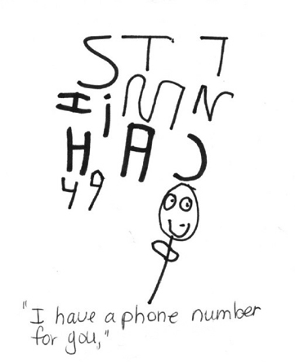
4/18
S. has started making numbers along with letters.

In this artwork, he said, “I have a phone number for you.” I asked, “Can we use the phone number on the phone in the playhouse?” He said, “Oh yeah!” He took his drawing and looked for letters and numbers on the phone. He pressed them and waited. Said, “I’m calling my mom. This is a phone number to call her.”

LLD 1, 3, 4, 9, 10; COG 3; VPA 1

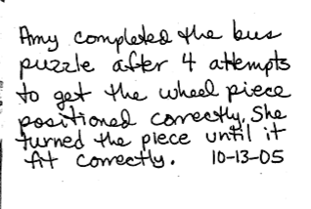
ATL-REG 6, PD-HLTH 4

Note about evidence: Adding details to a note or photograph can be a short cut to address multiple measures.

