Timely Tips

Gathering the necessary pieces of evidence to complete the DRDP can be a time consuming process. In an effort to support teachers with time saving tips, the checklist ideas included here may save a little of that precious commodity without sacrificing the observation of children in their normal routines, over time, and across different settings. A few DRDP measures allow specific demonstrated skills and knowledge to be documented by a teacher’s initials and date. These are recorded over time on monthly checklists and can supplement other pieces of documentation. Other measures require more substantial work samples and/or detailed anecdotal notes to accurately describe a child’s knowledge and demonstrated skills and cannot be adequately evidenced on a checklist.

Consider which specific skills or behaviors can be intentionally observed and recorded on a checklist with a confident, “Yes. S/he can do it.”

For example, a teacher may ask, “Do I see the child count up to five objects, in order?” If the answer is “Yes,” he/she will write initials and date in the appropriate box of the checklist. Teachers will want to ensure that this information is recorded so that discrepancies with what others have recorded may be discussed and resolved. If the child does not count up to five in order, and the environment provides many opportunities for counting to five, the teacher may simply continue taking observational notes of what the child does when they count. He/she may now provide documentation of what the child can do. The documentation will assist in planning experiences and interactions to scaffold the child’s learning.

Together, these forms of evidence and the ongoing use of checklists will inform individual and classroom curriculum planning. The absence of marks, as well as the presence of many initialed and dated observations on a checklist; provide important information in making continuous improvements to the classroom curriculum for this specific group of children.

Teachers may use their own checklist or sample checklists are available on the Desired Results (DR) Web site: www.desiredresults.us. Place the checklist on a clipboard with a cover sheet of construction paper so that the checklist will always remain covered and confidential when not taking observation notes.

The sample checklist, below, can be used to document children’s letter knowledge, (DRDP Measure LLD 9: Letter and Word Knowledge). Use a new checklist during the month’s alphabet letter activities. Have children’s names, or a more anonymous list of ID #s, listed down the first column and the alphabet letters across the top of the checklist. Along with teacher’s initials and date, use a “K” to document knowing the letters by sight. Knowing by sight is being able to recognize or point to a specific letter from a group of letters. Mark an “N” to evidence naming the letter. Naming a letter is being able to recall the name that identifies the specific letter.

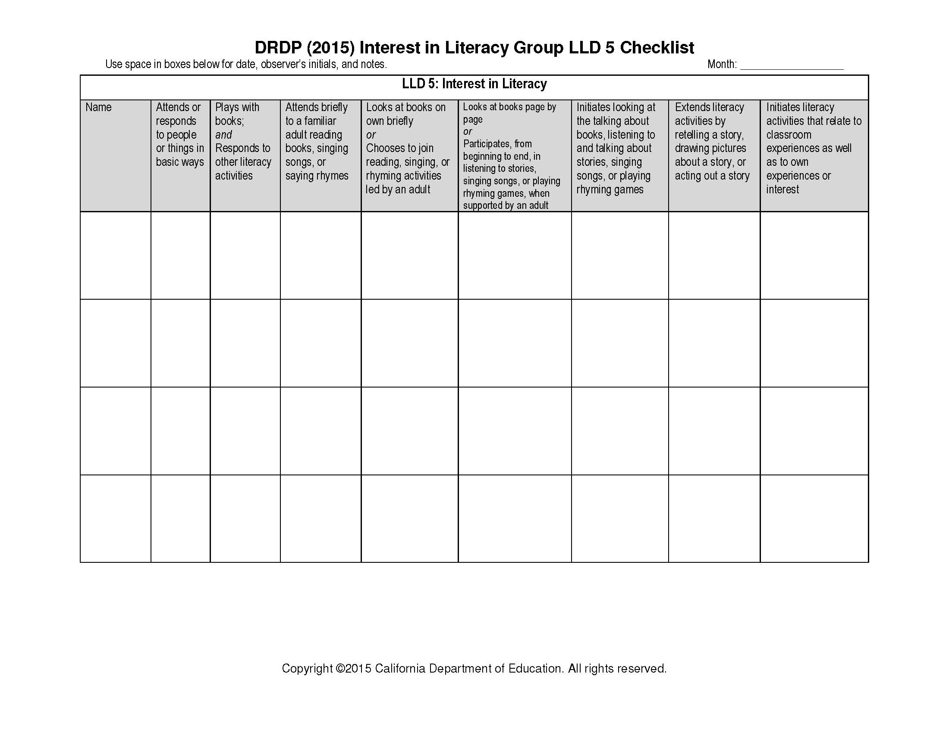
If desired, use the letter “U” for “upper case” or the letter “l” for “lower case” to note which letter format was present when the child demonstrated knowing the letter by sight or name. Use the letter “S” to document that the child understands the sound the letter makes in correspondence to the sound in words.

Consider writing, drawing, reading, and alphabet letter activities that occur during typical daily activities to plan observations. Have the month’s checklist and a pencil within easy reach and be intentional in observing and documenting children’s letter knowledge.

Another potential checklist is for DRDP Measure COG 3: Number Sense of Quantity. Use a copy of the checklist during the month’s normal, routine activities and plan to document children’s knowledge of numbers, quantity, and counting with initials and date. Notes may also be added on the back of the checklist. Remember to include the child’s name, your initials, and date.

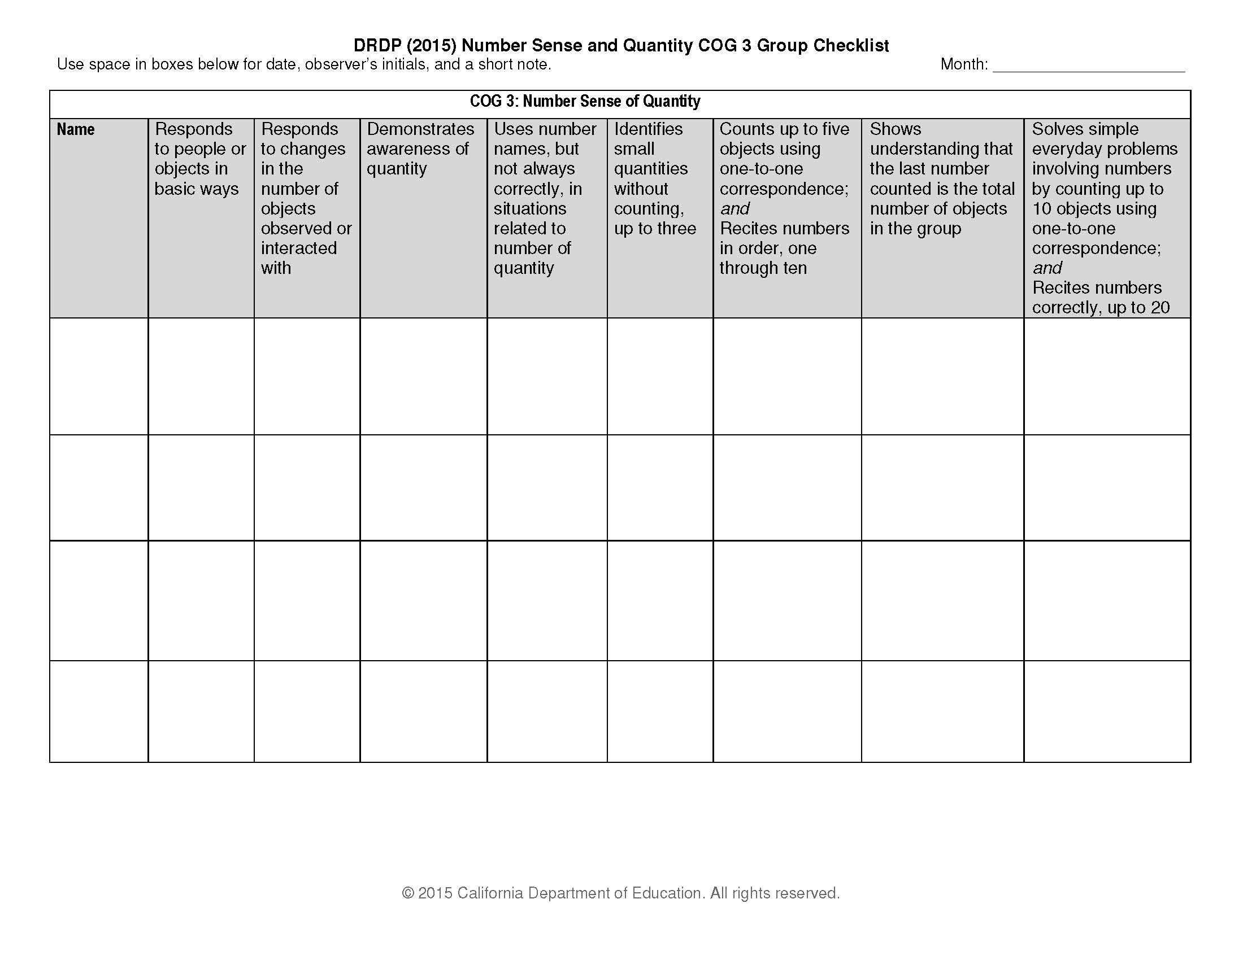

Think about the classroom learning centers, as well as times during the day when children will be using manipulatives, counters, or distributing snacks, utensils, etc. to small groups. Have the month’s checklist handy and have staff add initials and date for each child who demonstrates the listed skills and behaviors.

A third sample checklist supports gathering evidence on children’s physical development, including DRDP Measure PD-HLTH 1: Perceptual-Motor Skills and Movement Concepts and Measure PD-HLTH 4: Fine Motor Manipulative Skills. As with the previous samples, prepare for observations by having the month’s copy of the checklist, a pencil, and a plan for where and when an opportunity exists to see children demonstrating these skills.

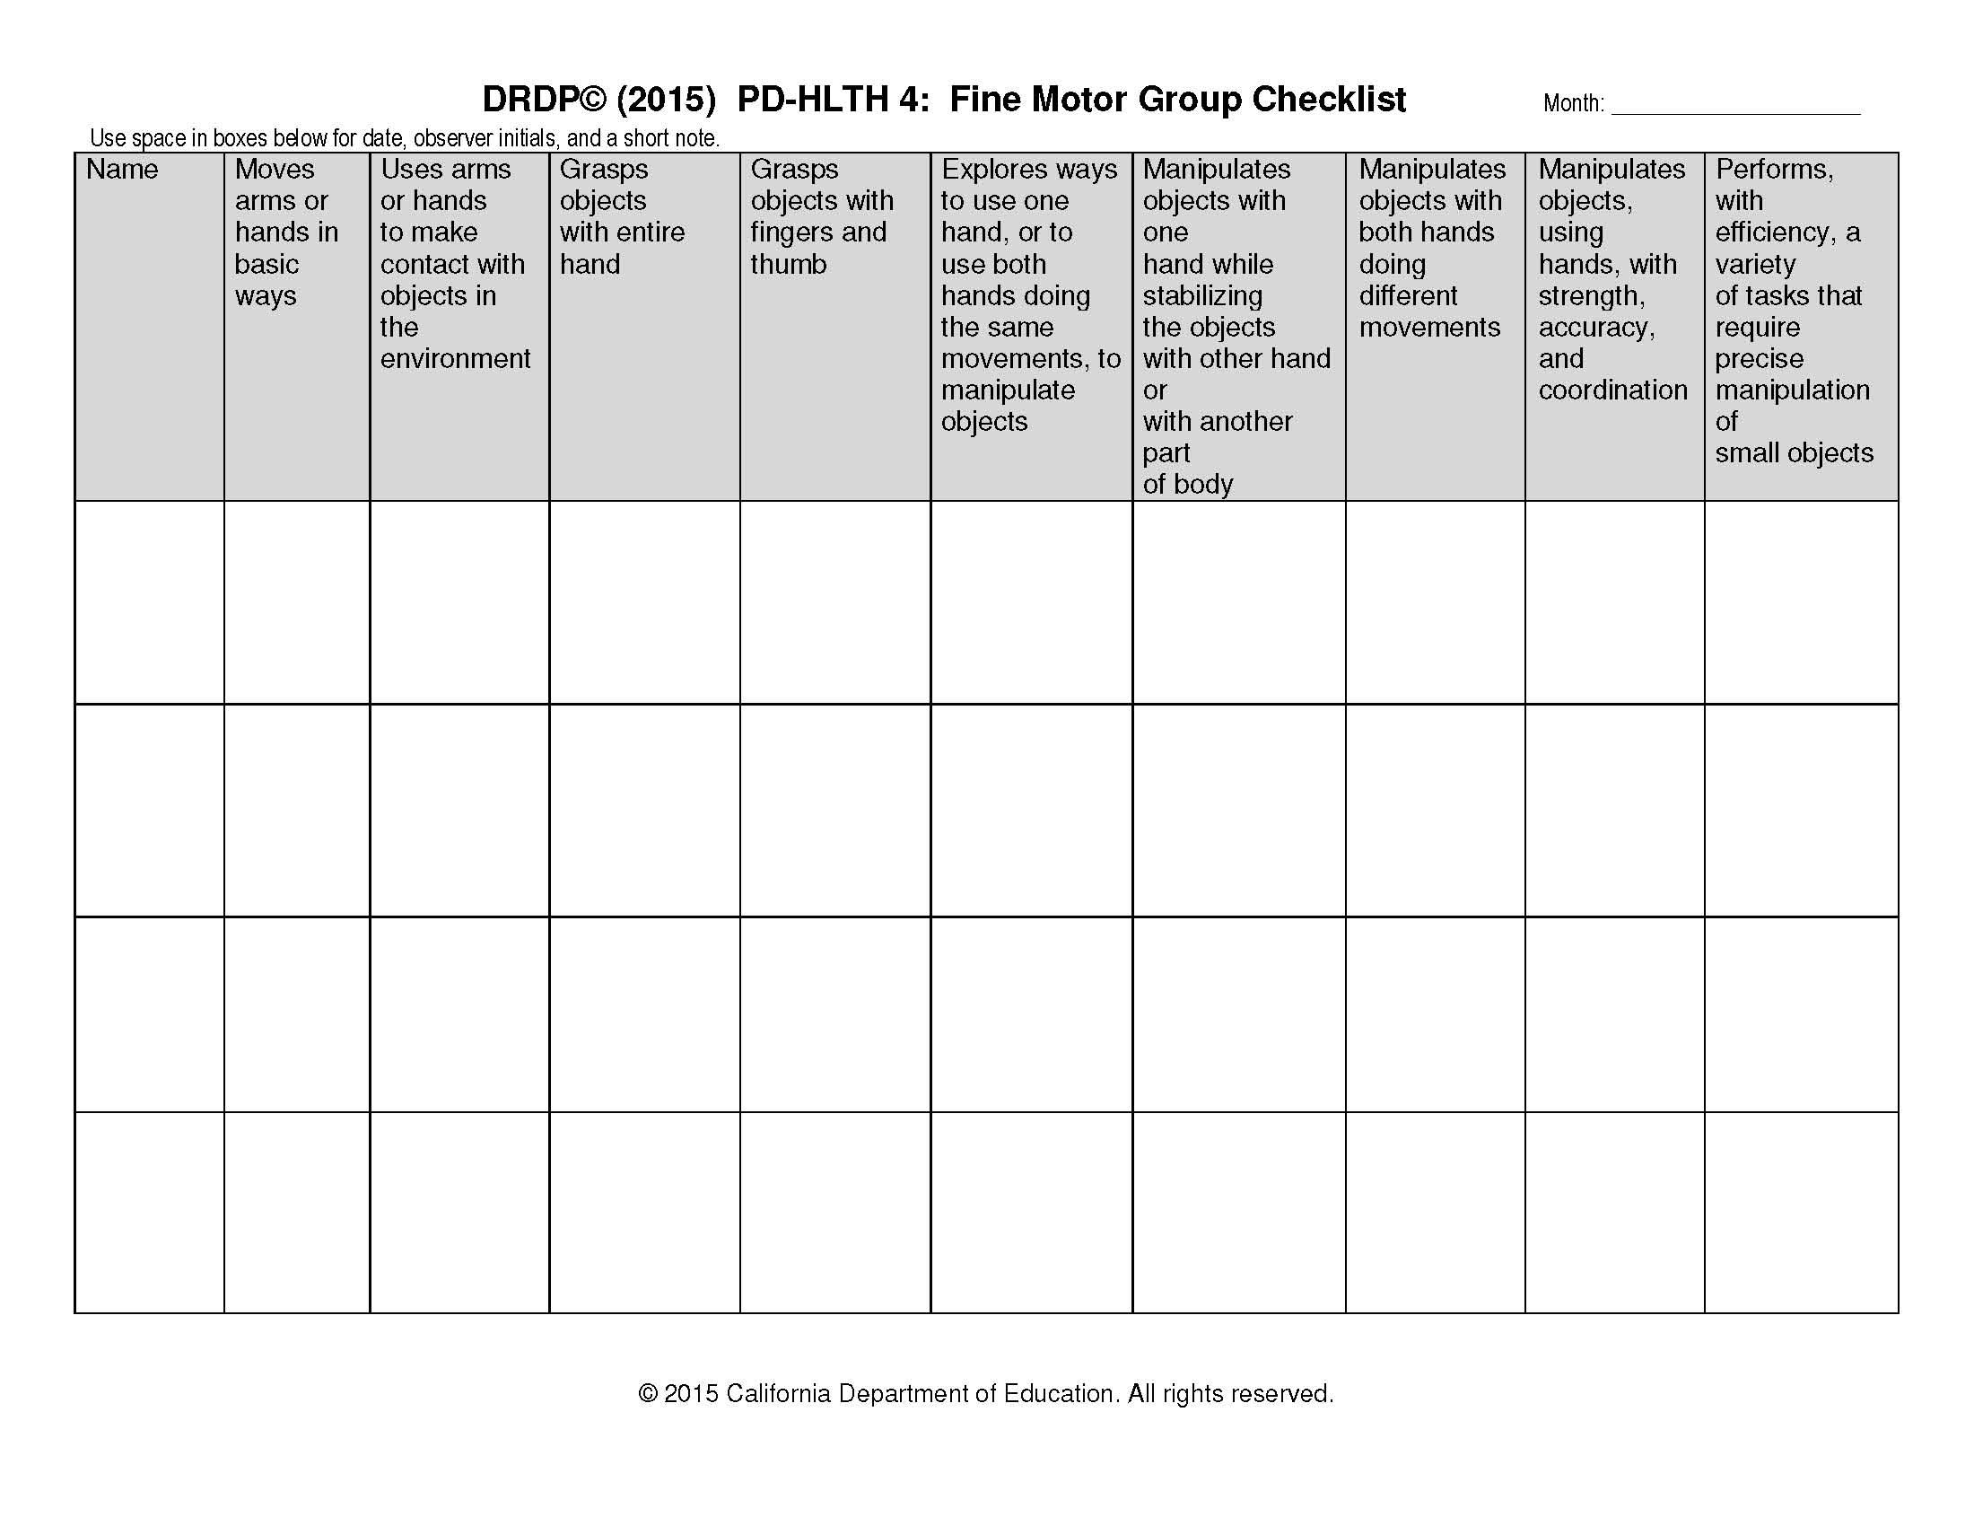

Be strategic in making observations and evidence records. Remember that a single piece of evidence may document two or more measures. For example, a child’s manipulation of small counters for counting in Measure COG 3: Number Sense of Quantity may also provide evidence of eye-hand coordination for Measure PD-HLTH 4: Fine Motor Manipulative Skills.

Set aside a regular time once a month to review checklists to ensure evidence is gathered for each child and to support plans for gathering documentation for the next month.

