Timely Tips – Infant/Toddler

Gathering the necessary pieces of evidence to complete the DRDP (2015) can be a time consuming process. In an effort to support teachers with time saving tips, the checklist ideas included here may save a little of that precious commodity without sacrificing the observation of children in their normal routines, over time, and across different settings. Some of the infant/toddler, DRDP-IT (2015), measures allow specific demonstrated skills and knowledge to be documented by a teacher’s initials, date, and a very brief comment. These are recorded over time on monthly checklists and can supplement other pieces of documentation. Other measures require more substantial work samples and/or detailed anecdotal notes to accurately describe a child’s knowledge and demonstrated skills and cannot be adequately evidenced on a checklist.

Consider which specific skills or behaviors can be intentionally observed and recorded with a brief, supporting comment (such as child’s focus, response, or materials involved) on a checklist with a confident, “Yes. S/he can do it!”

For example, a teacher may ask, “Do I see the child following simple safety rules (Measure 35)?” If the answer is “Yes,” the teacher will write initials and date in the appropriate box of the checklist, indicate which rule and whether or not the child was reminded to follow the rule (check “yes” or “no”), and add a comment as needed for clarity. Teachers will want to ensure that this information is recorded for reflection and so that discrepancies with what others have recorded may be discussed and resolved. If the child does not yet follow simple safety rules, the teacher may simply continue taking observational notes of what the child does when the child feels insecure or unsafe, or responds with reflexes to stimuli. The documentation will assist in planning experiences and interactions to scaffold the child’s learning and development. A sample checklist and two sample entries is provided in this document.

Together, a variety of forms of evidence, including the ongoing use of checklists, will inform individual and classroom curriculum planning. Both the absence and presence of marks (initialed and dated observations) on a checklist provide important information in making continuous improvements in responses to and support for individual children, as well as the classroom environment and curriculum for this specific group of children.

Teachers may use their own checklist, or sample checklists are available on the Desired Results (DR) Website: http://www.desiredresults.us/resource_drdp2015.html. Place the checklist on a clipboard with a cover sheet of construction paper so that the checklist will always remain covered and confidential when not taking observation notes.

The sample checklist, below, can be used to document children’s interests in books, stories, songs, and rhymes, interests that can help support literacy development. Have children’s names, or a more anonymous list of identification (ID) numbers, listed down the first column and the developmental levels for this measure across the top of the checklist.
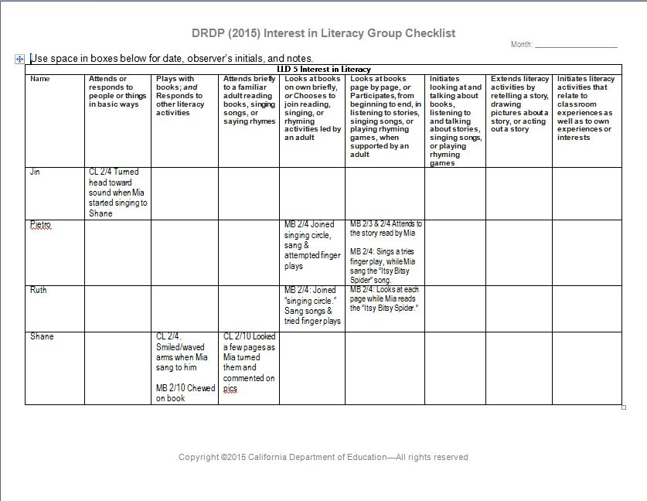

When a child demonstrates a behavior described in the measure, a staff member records initials, date, and a brief comment to provide documentation and support later reflection for planning purposes. A brief but meaningful note at the time will make reflection and planning more effective later. A few sample entries have been included.

Have the month’s checklist and a pencil within easy reach and be intentional in observing and documenting children’s interest in literacy. Remember that early explorations that can lead to literacy include a child being interested in the physical properties of books (including mouthing books) or simply listening briefly to songs, rhymes, talk about pictures, or book reading.

Another potential checklist is for Cognition 2: Classification. Use a copy of the checklist during the month’s normal, routine activities and plan to document children’s attempts to match or sort things. Notes may also be added on the back of the checklist. Remember to include the child’s name, your initials, date, and brief note, such as type of activity or objects being matched or sorted.

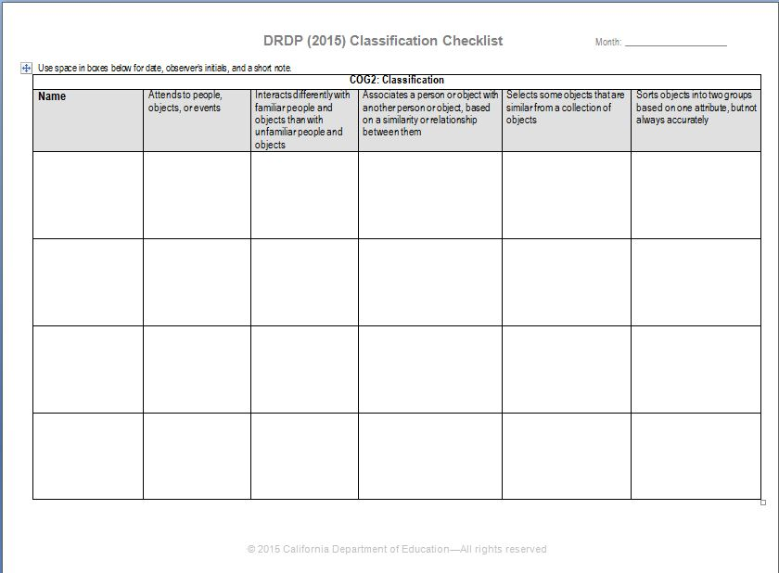

Think about the classroom learning centers, as well as times during the day when children will be exploring objects that lend themselves to matching or sorting; playing in the dramatic play area (with dishes, dress-up clothes, etc.); and when children might help to distribute snacks, utensils, etc. to a small group of children. Have the month’s checklist handy. For each child who demonstrates the listed skills and behaviors, staff members record initials, date, and type of activity or objects.

The next sample checklist supports gathering evidence on children’s physical development, specifically, PD-HLTH 4: Fine motor manipulative skills. As with the previous samples, prepare for observations by having the month’s copy of the checklist, a pencil, and a plan for where and when opportunities exists to see children demonstrating these skills. There are many opportunities in many places for young children to practice and develop fine motor skills!

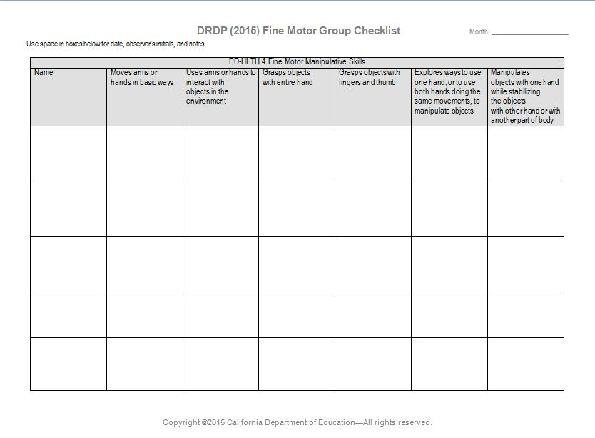

Be strategic in making observations and evidence records. Remember that a single piece of evidence may document multiple measures. For example, a child’s matching or grouping of objects in Cognition 2: Classification may also provide evidence for COG 3: Number Sense of Quantity and evidence for grasp and manipulation of objects for PD-HLTH 4: Fine Motor Manipulative Skills.

Set aside a regular time once a week, or at least once a month, to review checklists to ensure evidence is gathered for each child, to reflect and plan for effective support of children’s development, and to support plans for gathering documentation for the next month.

