Title | Quantity | Price | Total
DVDs
Getting to Know You Through Observation DVD |  | $12.00 | $
Watching My Child Grow DVD |  | $12.00 | $
Mini Measures
DRDP© (2015) PS view Mini Measures in Color |  | $15.00 | $
DRDP© (2015) IT view Mini Measures in Color |  | $15.00 | $
DRDP-K© (2015) Mini Measures in Color |  | $15.00 | $
 | Subtotal |  | $
 | Shipping & Handling  (see chart) |  | $
 | TOTAL |  | $
Payment Method (no credit cards)
Check
Purchase Order
(For orders $50 or more)
Shipping & Handling Charges
Standard UPS | 1-3 weeks | $0
Rush Delivery via UPS | UPS 2-Day  UPS overnight | $20 per order  $30 per order

Shipping Information (Physical Addresses only, No P.O. Boxes)

Name:

Address (No P.O. Box):

City, State, Zip Code:

Telephone number:

E-mail address:

Mail order form with check payable to WestEd for Total Amount Due to:

WestEd
DRTTA Attn: Resource Order
333 N. Lantana St. Suite 277
Camarillo, CA 93010
1-800-770-6339 Fax: 805-465-4444

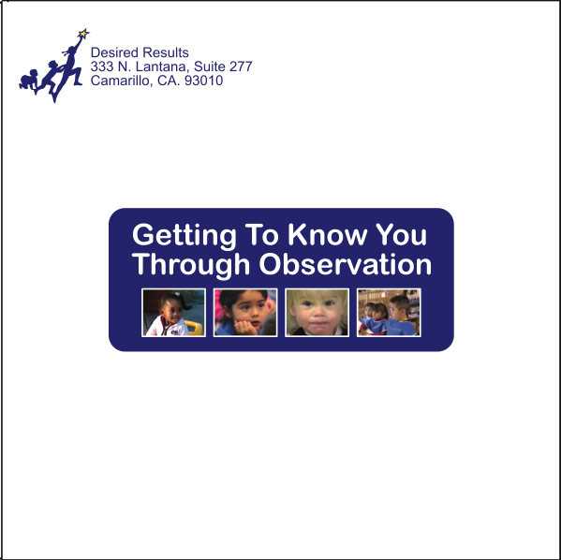
The Getting to Know You Through Observation DVD illustrates the importance of observation in early childcare and education settings. It offers strategies for developing accurate and reliable systems of observation and recording. The DVD is subtitled in Spanish. To download the accompanying Getting to Know You Through Observation Trainer’s Guide and the Training Workbook, visit www.desiredresults.us.

Watching My Child Grow is an introduction for families to the Desired Results system. It is dubbed in English, Spanish and Mandarin.
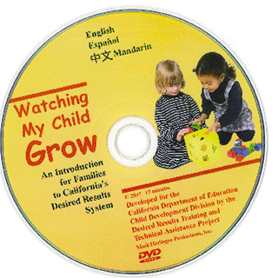

Mini Measures are a pocket-sized format designed to assist teachers working with the DRDP© (2015) in their observations of children. The color versions of the DRDP (2015) © (Preschool view and Infant/Toddler view) and the DRDP-K© (2015) Mini Measures divide the developmental domains by color, providing a quick visual reference point for the measures.

To order the Getting to Know you Through Observation DVD by credit card, please visit http://www.wested.org/resources/getting-to-know-you-through-observation/

