DRDP (2015) Watch My Child Grow (Sample)
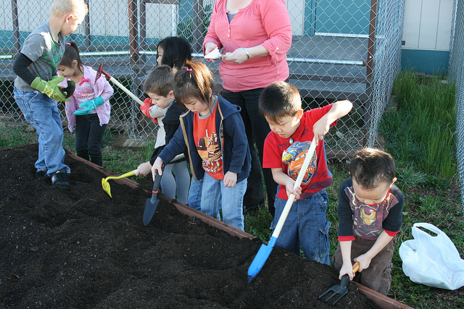 | 9/18/2014  J. picked up the shovel and said “let’s dig a hole to put the seeds in. But it can’t be too deep, because the seeds need to have sun to grow.” He then told C. “come over, there’s room for you too” and gave C. a shovel when he joined us.
- ATL-REG 1: Attention Maintenance  - ATL-REG 2: Self-Comforting  - ATL-REG 3: Imitation  - ATL-REG 4: Curiosity and Initiative in Learning  - ATL-REG 5: Self-control of Feelings and Behavior  - ATL-REG 6: Engagement and Persistence  - ATL-REG 7: Shared Use of Space and Materials  - SED 1: Identity of Self in Relation to Others  - SED 2: Social and Emotional Understanding  - SED 3: Relationships and Social Interactions with Familiar Adults  - SED 4: Relationships and Social Interactions with Peers  - SED 5: Symbolic and Sociodramatic Play  - LLD 1: Understanding of Language (Receptive)  - LLD 2: Responsiveness to Language  - LLD 3: Communication and Use of Language (Expressive)  - LLD 4: Reciprocal Communication and Conversation  - LLD 5: Interest in Literacy  - LLD 6: Comprehension of Age-Appropriate Text  - LLD 7: Concepts About Print  - LLD 8: Phonological Awareness  - LLD 9: Letter and Word Knowledge  - LLD 10: Emergent Writing  - ELD 1: Comprehension of English (Receptive English)  - ELD 2: Self-Expression in English (Expressive English)  - ELD 3: Understanding and Response to English Literacy Activities  - ELD 4: Symbol, Letter, and Print Knowledge in English  - COG 1: Spatial Relationships  - COG 2: Classification  - COG 3: Number Sense of Quantity  - COG 4: Number Sense of Math Operations  - COG 5: Measurement | - COG 6: Patterning  - COG 7: Shapes  - COG 8: Cause and Effect  - COG 9: Inquiry Through Observation and Investigation  - COG 10: Documentation an Communication of Inquiry  - COG 11: Knowledge of the Natural World  - PD-HLTH 1: Perceptual-Motor Skills and Movement Concepts  - PD-HLTH 2: Gross Locomotor Movement Skills  - PD-HLTH 3: Gross Motor Manipulative Skills  - PD-HLTH 4: Fine Motor Manipulative Skills  - PD-HLTH 5: Safety  - PD-HLTH 6: Personal Care Routines: Hygiene  - PD-HLTH 7: Personal Care Routines :Feeding  - PD-HLTH 8: Personal Care Routines: Dressing  - PD-HLTH 9: Active Physical Play  - PD-HLTH 10: Nutrition  - HSS 1: Sense of Time  - HSS 2: Sense of Place  - HSS 3: Ecology  - HSS 4: Conflict Negotiation  - HSS 5: Responsible Conduct as a Group Member  - VPA 1: Visual Art  - VPA 2: Music  - VPA 3: Drama  - VPA 4: Dance

